JUNIOR SCHOOL

2024 QUESTIONS

G8 HOMESCIENCE

- State the guidelines to be followed when grilling different types of foods to ensure the food is well cooked.
- ………………………………………………………….……………………………..………………………………………..
- …………………………………………………………….…………………………………………… ……………………….
- …………………………………………………………………………………………………………………………………..
- …………………………………………………………………………………………………………………………………..

- Name the following cooking tools
- Two prong fork | 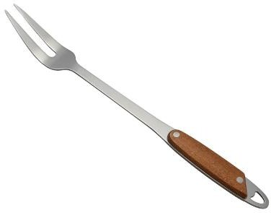
Skewer | 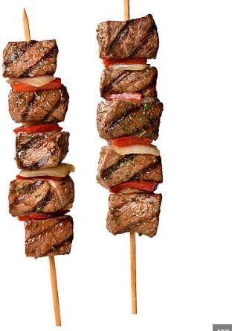
Tongs | 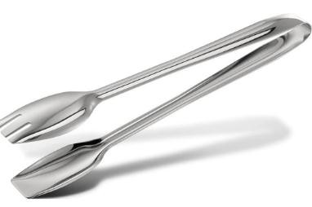

- State the desirable properties of linen
      - …………………………………………………………………………….………………………………
      - …………………………………………………………………………………………………………..
      - …………………………………………………………………………………..………………………..
      - ………………………………………………………………………..………………………………….
- State the undesirable properties of linen

      - …………………………………………………………………………………….
      - …………………………………………………………………………………….
      - ……………………………………………………………………………………..
- State the challenges experienced or faced when buying household goods and services.
- …………………………………………………………………………………………………………………………….
- ……………………………………………………………………………………………………………………………
- ……………………………………………………………………………………………………………………………
- …………………………………………………………………………………………………………………………..
- What are the ways of Saving Income when buying household goods and services?
    - ……………………………………………………………………………………………………….
    - ……………………………………………………………………………………………………….
    - ………………………………………………………………………………………………………..
    - …………………………………………………………………………………………………………
- There are several ways of buying various household goods and services from the sale outlets. Name a few.
  - ……………………………………………………………………………………….
  - ………………………………………………………………………………………..
  - ……………………………………………………………………………………………
- State three reasons for having a kitchen garden
- …………………………………………………………………………………………..
- ……………………………………………………………………………………………
- ……………………………………………………………………………………………
- State three types of kitchen gardens.

……………………………………………………………………………………….

………………………………………………………………………………………

………………………………………………………………………………………

State three methods of cooking food:
- ……………………………………………………
- ………………………………………………………
- ………………………………………………………
- Identify the methods of heat transfer when cooking below
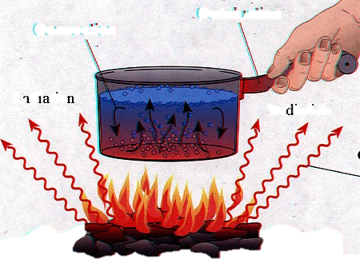

- What is meant by the following terms?
Dextrinisation: .................................................................................................................................................................................................................................................................................................................
Gelatinisation: …………………………………………………………………………………………………………………………………………………………………………………………………………

Mention five ways used to retain nutrients while cooking
- ………………………………………………………………………………………..
- ……………………………………………………………………………………….
- ……………………………………………………………………………………….
- ……………………………………………………………………………………….
- ………………………………………………………………………………………

- State the factors to consider when setting a table.
- …………………………………………………………………….
- …………………………………………………………………….
- ……………………………………………………………………..
- …………………………………………………………………….

