JUNIOR SCHOOL

INTEGRATED SCIENCE

2024 Marking scheme

- Name the following parts of a Bunsen burner.
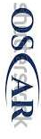
- Name two apparatus used for measuring length.
- Metre rule,
- rulers,
- tape measure,
- Vernier callipers
- Name three protective wear for safety in the laboratory.
- Gloves
- Overall
- Safety goggles
- Facemask
- Headgear

- What are the names of the following laboratory apparatus?

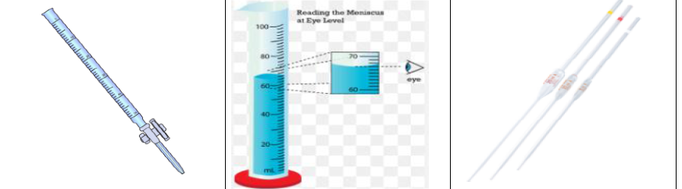
Pipette Graduated Cylinder Burette

- Identify three properties of gases:
- Gases have neither a fixed shape nor a fixed volume.
- Gases can be compressed easily.
- Gases have the least density among the three.
- Intermolecular forces of attraction are weakest.
- The space between the gas particles is large.

- Name three heat instruments used in the lab for heating purposes.
- Portable burner
- Bunsen burner
- Candle
- Spirit lamp

- In an experiment to demonstrate a certain aspect in liquids, Mwangi put potassium Manganate (vii) in water and observed the process

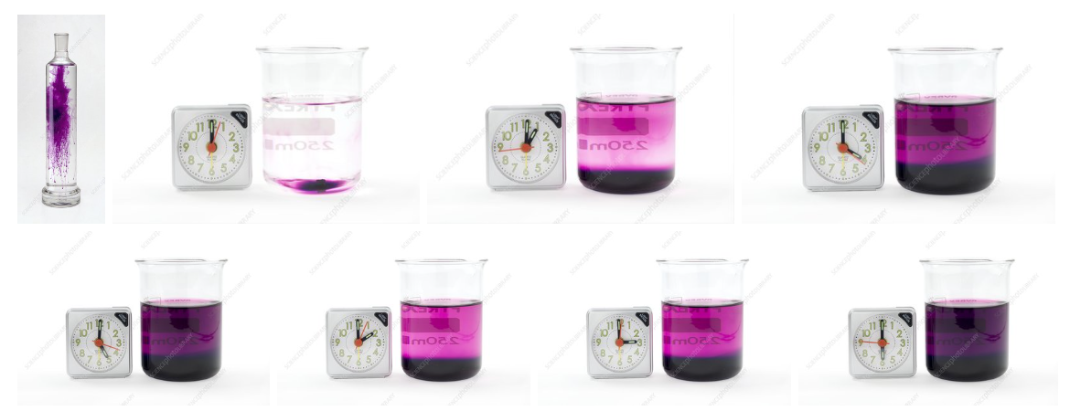

When the crystals of potassium permanganate were kept in water, the purple-coloured crystals of potassium permanganate broke further into smaller particles and occupied the space between the molecules of water imparting a purple colour to the water.
- So this experiment was to show
Diffusion in liquids.
- What was the use of the clock in the experiment?
A clock being used to time how long it takes for the purple colour to spread through the water as the potassium permanganate dissolves
- What is the chemical symbol of potassium permanganate?
Kmo₄
- What is the colour of potassium permanganate?
Purple
- Name the following states of matter

- Identify four basic science skills one gains in science practical.
- Manipulation
- Observation
- Calculation
- Prediction
- Measurement etc

- Name the following changes of state of matter

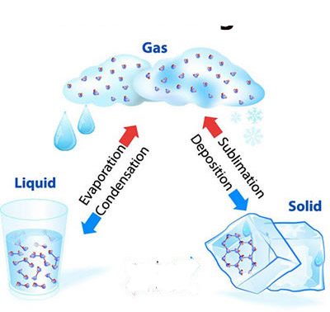

- List three common examples of changes of state of matter that occur in everyday life:
- Ice melting: When ice at 0°C is heated, it changes from solid state to liquid state and starts melting.
- Frost formation: When the temperature drops below 0°C, water vapour in the air condenses directly into solid ice crystals.
- Water boiling: When water is heated, it changes from liquid state to gas state (steam).
- Condensation of water vapour: When water vapour in the air cools below 100°C, it changes from gas state to liquid state and condenses to form liquid water droplets.
- Sublimation: An example of sublimation is when solid dry ice (frozen carbon dioxide) changes into carbon dioxide gas without melting.

- Name two laboratory apparatus used for measuring mass of substances.
- Electric balance
- Double beam balance
- Triple beam balance

- Give two differences between luminous and non-luminous flame.
Luminous flame | Non-luminous flame
Yellow/orange in colour | Blue in colours
Used for lighting | Used for heating
Has 4 regions and burns quietly | Has 3 regions and noisy
Produced when air hole is closed | Produced when air hole is open
Produces soot | Does not produce soot
Its wavy and large | Its straight

State two causes of changing states of matter
- Change in Temperature: The temperature change occurs in states of a matter when it undergoes heat transfer to its surroundings.
- Change in Pressure: The change in pressure occurs in states of a matter only when it undergoes liquefaction.

Safety precautions to prevent burns and scalds.
- ⬄ Wear kitchen gloves or use a piece of cloth to hold hot kitchen utensils.
- ⬄ Keep hot liquids out of reach of children.
- ⬄ Do not leave children unattended around fires or near hot surfaces.
- ⬄ Avoid wearing loosely hanging clothes near fires.
- ⬄ Always direct steam away from your body when opening lids while cooking food.
- What is the area of the Trapezium
20cm

10cm

30cm
Area =1/2 (sum of parallel side) x perpendicular distance between the lines
= 1/2 (a+b)h
= $\frac{1}{2}$*(20cm+30cm)*10cm
=250cm²

- What are the names and functions of the following first aid items?

 | ITEM | PHOTOGRAPH | FUNCTION
1 | Bandages. | 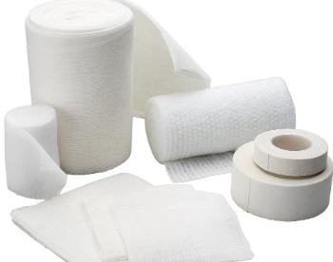 | Hold dressing in place to help control bleeding and protect against infection.
2 | Cotton wool. | 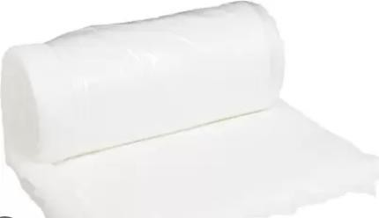 | It is used for cleaning and protecting the wound.
3 | Surgical gloves. | 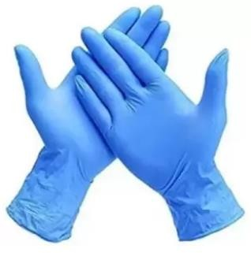 | Cover our hands and prevent transmission of diseases.
4 | Safety pins. | 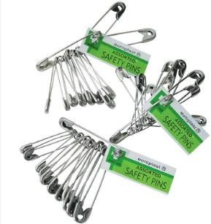 | Are used to secure wraps and bandages

First aid for burns and scalds.
- Wash your hands.
- Wear gloves.
- Move the injured person from the source of heat.
- Cool the burn or scald by pouring cold water on it for about 10 minutes.
- Remove jewellery or clothing around the wound. Do not try to remove the clothing it is is stuck to the skin.
- Cover the wound with a loosely hanging piece of cloth.
- Seek further medical assistance for serious burns and scalds

Outline the Causes of a sprain in the following body parts

Body part | Cause of sprain
Ankle. | - Walking, running or exercising on an uneven surface.  - Landing unsteadily from a jump.
Knee | - Overstretching during an athletic activity.
Wrist | - Landing on an outstretched hand during a fall.
thumb | - Hitting your thumb on a hard surface.

- State the Factors that contribute to road accidents.

  - Failure to observe road safety signs and signals by drivers, passengers and pedestrians.
  - Speeding of vehicles and motorbikes.
  - Failure of pedestrians to use designated crossing areas like foot bridges and pedestrian’s crossing.
  - Use of mobile phones, earphones and other electronic gadgets while driving or crossing the road.
  - Driving under the influence of alcohol and drugs.
  - Use of medicines that may cause drowsiness.
  - Overtaking carelessly.
  - Driving too close behind another vehicle.
  - Being distracted while using the road. For example, reading billboards, talking or being in deep thoughts.
  - Unroadworthy vehicles.
  - Driving at night with poor eyesight.
  - Bad weather which affects visibility.

- Explain the Measures pedestrians can observe to be safe when using roads to avoid accidents.

- Use a footpath while walking along the road.
- Wear reflective jackets at night.
- Children should walk in the company of an adult.
- Walk in organized groups when crossing a road.
- Cross only when the road is safe and clear.
- Do not run while crossing the road.
- Use the pedestrian crossing or footbridges where the pedestrian’s crossing light is on.
- Walk on the right hand of the road to see oncoming vehicles.

- What is the meaning of the following road sign?

 | Danger ahead
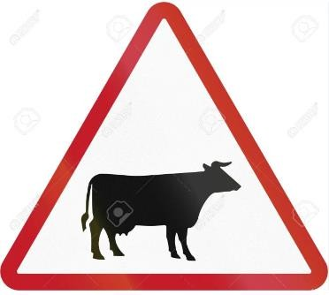 | Animal crossing
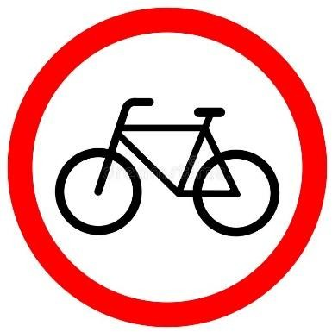 | Cyclist only
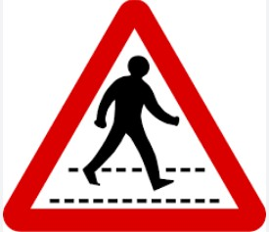 | Pedestrian crossing.
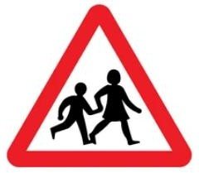 | Children crossing.

- State the physical changes that adolescents undergo during the period of adolescence.

 | Physical changes in Boys |  | Physical changes in girls.
1 | Increase in weight and height | 1 | Increase in weight and height.
2 | Chest and shoulders broaden. | 2 | The hip region broadens.
3 | Growth of hair on the face or chin(beards) | 3 | Breasts enlarge.
4 | They experience wet dreams. | 4 | Hair grows under the armpits and around the pubic area.
5 | Growth of hair on the chest, under the armpits and around the pubic area. | 5 | Pimples may appear on the face.
6 | Pimples may appear on the face. | 6 | Menstruation begins.
7 | Breaking of voice. The voice becomes deeper. | 7

- Identify the names of the following items used by adolescent girls
Reusable pads | Disposable pads. | Tampons | Menstrual cup
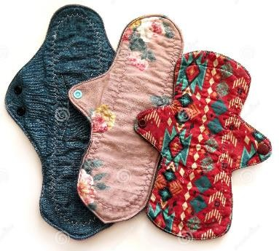 | 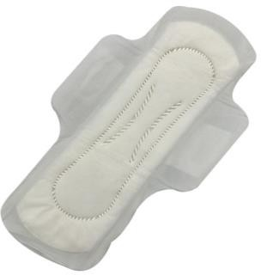 | 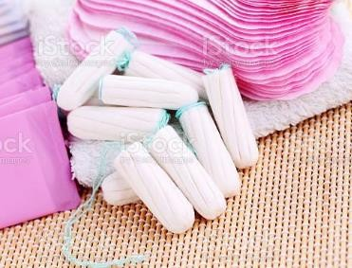 | 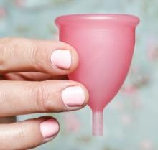

State measures of management of menstrual hygiene.
- On the onset (start) of menstruation, girls are advised to bathe properly and regularly to avoid infections in the reproductive system.
- Pack enough sanitary towels in your bag if you are leaving the house.
- Change sanitary towels frequently to avoid infections and soaking of the towel which may stain clothes.
- Wrap disposable sanitary towels properly after use. Dispose them correctly in pit latrines or in sanitary pad bins.
- Reusable sanitary towels must be washed properly and dried in the sunlight. The sun’s heat dries the towels and naturally sterilizes them. The materials should be stored in a clean and dry place to avoid contamination.

