JUNIOR SCHOOL

INTEGRATED SCIENCE

2024 QUESTIONS

- Name the following parts of a Bunsen burner.

- Name two apparatus used for measuring length.
- ………………………………………
- ………………………………………

- Name three protective wear for safety in the laboratory.
- ………………………………………
- ………………………………………
- ………………………………………

- What are the names of the following laboratory apparatus?

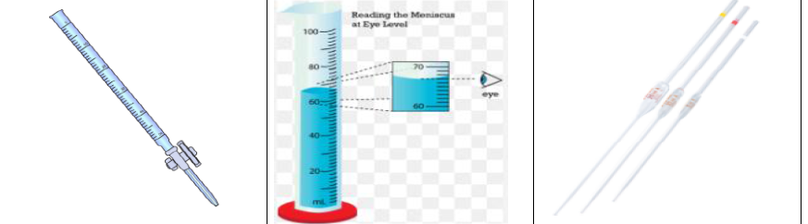

- Identify three properties of gases:
- ………………………………………………………………………………….
- ………………………………………………………………………………….
- …………………………………………………………………………………..

- Name three heat instruments used in the lab for heating purposes.
- …………………………………………
- …………………………………………
- ………………………………………….

- In an experiment to demonstrate a certain aspect in liquids, Mwangi put potassium Manganate (vii) in water and observed the process

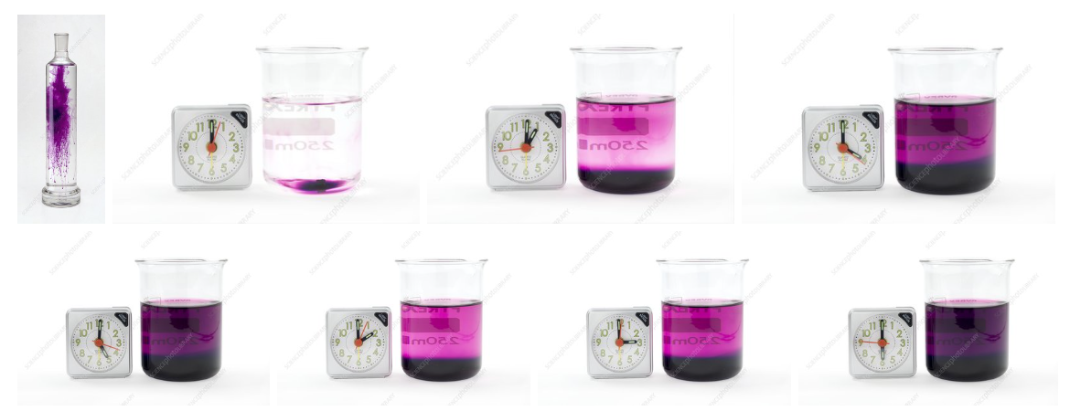

When the crystals of potassium permanganate were kept in water, the purple-coloured crystals of potassium permanganate broke further into smaller particles and occupied the space between the molecules of water imparting a purple colour to the water.
- So this experiment was to show
………………………………………………………………….
- What was the use of the clock in the experiment?
……………………………………………………………………………………………………………………………………………………………………………….
- What is the chemical symbol of potassium permanganate?
…………………………………………………………………………………….
- What is the colour of potassium permanganate?
…………………………………..

- Identify four basic science skills one gains in science practical.
- …………………………………….
- …………………………………….
- …………………………………….
- …………………………………….

- Name the following changes of state of matter

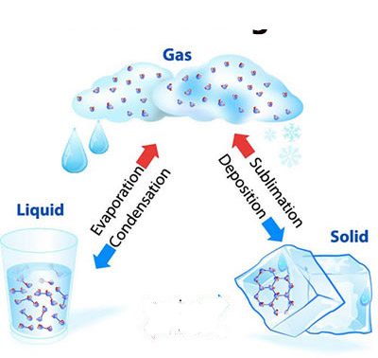
- List three common examples of changes of state of matter that occur in everyday life:
- ……………………………………………………………………………………
- ……………………………………………………………………………………
- …………………………………………………………………………………..

- Name two laboratory apparatus used for measuring mass of substances.
- ……………………………………………………………………..
- …………………………………………………………………….

- Give two differences between luminous and non-luminous flame.
Luminous flame | Non-luminous flame

State two causes of changing states of matter
- ……………………………………………………………………………………………
- …………………………………………………………………………………………..

State the safety precautions to prevent burns and scalds.
- ………………………………………………………………………………………….
- …………………………………………………………………………………………

- What is the area of the Trapezium
20cm

10cm

30cm

- What are the names and functions of the following first aid items?

 | ITEM | PHOTOGRAPH | FUNCTION
1 | Bandages. | 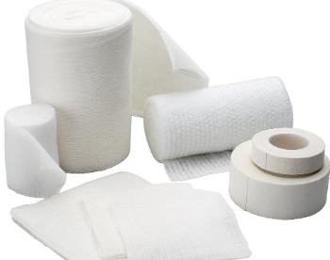
2 | Cotton wool. | 
3 | Surgical gloves. | 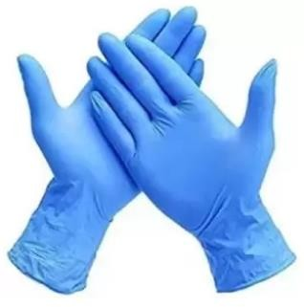
4 | Safety pins. | 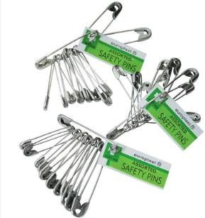

First aid for burns and scalds.
- ……………………………………………………………………………………….
- ……………………………………………………………………………………….
- ………………………………………………………………………………………

Outline the Causes of a sprain in the following body parts

Body part | Cause of sprain
Ankle.
Knee
Wrist
thumb

- State the Factors that contribute to road accidents.

  - …………………………….…………………………………………………….
  - …………………………………………………………………………………..
  - ………………………………………………………………………………….

- Explain the Measures pedestrians can observe to be safe when using roads to avoid accidents.

- ……………………………………………………………………………………………….
- ………………………………………………………………………………………………..

- What is the meaning of the following road sign?


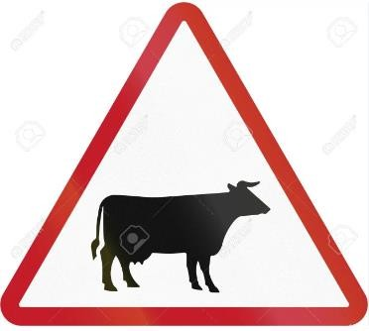

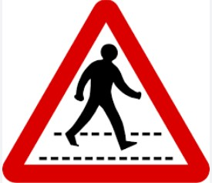
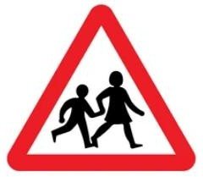

- State the physical changes that adolescents undergo during the period of adolescence.

 | Physical changes in Boys |  | Physical changes in girls.
1
2
3
4

- Identify the names of the following items used by adolescent girls
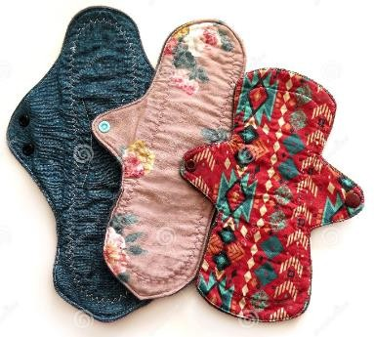 | 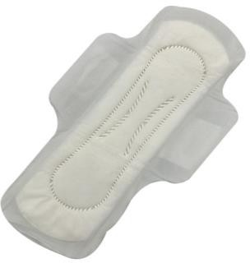 | 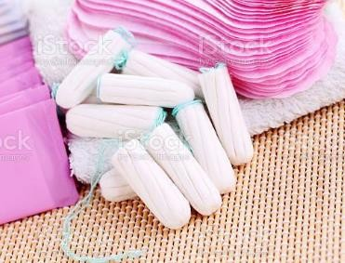 | 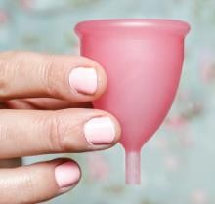

State measures of management of menstrual hygiene.
- ………………………………………………………………………………………
- ……………………………………………………………………………………….
- ………………………………………………………………………………………..

