JUNIOR SCHOOL

2024 QUESTIONS

G8 SOCIAL STUDIES

Answer all questions

- Identify the following maps

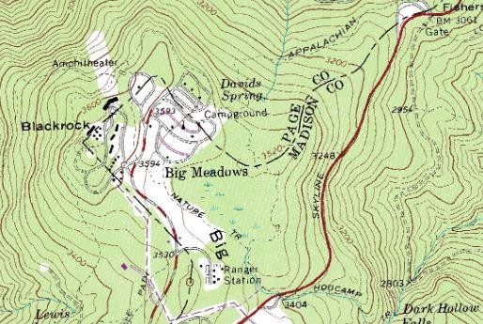
…………………………………………..


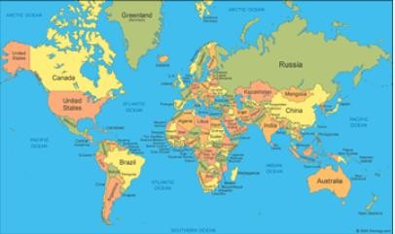

…………………………………………..

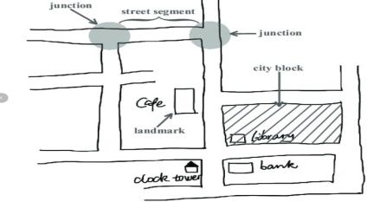

🢒

……………………………………………

- Discuss the origin of the solar system under the following theories
  - The passing star theory
- ………………………………………………………………………………..
- ………………………………………………………………………………..
- …………………………………………………………………………………
- …………………………………………………………………………………

  - The nebula cloud theory
- …………………………………………………………………………………..
- …………………………………………………………………………………..
- …………………………………………………………………………………..
- ………………………………………………………………………………….

- State the names that describes the shape of the earth
- ………………………………..
- ……………………………….
- ………………………………..

- What are the Effects of Rotation of the Earth
- ……………………………………………………………………………….
- ……………………………………………………………………………….
- ……………………………………………………………………………….
- What are the effects of Revolution of the earth?
- ………………………………………………………………………………….
- …………………………………………………………………………………..
- …………………………………………………………………………………..

- If the time in Monrovia , Liberia ,12⁰W is 8:00am,what is the time at Addis Ababa, Ethiopia, 38 ⁰E?

- List down four proofs that the earth is spherical
- ………………………………..…………………………………………………
- …………………………………………………………………………………..
- ………………………………………………………………………………….
- …………………………………………………………………………………
- Identify the following parts of internal structure of the earth

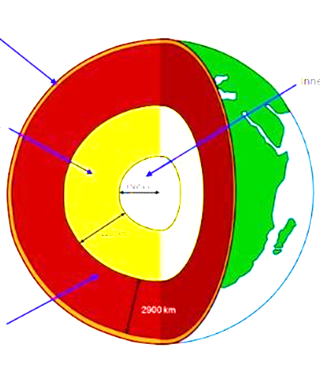

State the characteristics of the earth’s Core
- …………………………………………………………………….
- …………………………………………………………………….
- …………………………………………………………………….

State the Composition of the Atmosphere
- ……………………………………………
- …………………………………………..
- …………………………………………..

- a) Name the four main zones of the atmosphere
- ………………………………
- ……………………………….
- ……………………………….
- …………………………………

- The table below shows rain fall and temperature in town x use it to answer the questions that follow
Months | JA | FE | MA | AP | MA | JUN | JUL | AU | SE | OC | NO | DE
Temp °C | 23 | 24 | 26 | 28 | 29 | 28 | 26 | 26 | 26 | 30 | 28 | 25
Rainfall mm | 3 | 0 | 3 | 1 | 18 | 500 | 720 | 408 | 300 | 70 | 15 | 0

- Calculate
- The total annual rainfall

- The mean monthly rainfall

- The annual range of temperature

- The mean annual temperature (2mks)

- Using the table indicate the following
- The wettest month …………………………………

- The hottest month …………………………………………

- The coolest month …………………………………………
- What are the factors to be taken into account when sitting a weather station
- ……………………………………………………………………………….
- ……………………………………………………………………………….
- ……………………………………………………………………………….

Write what element of weather they measure
- Thermometer- ……………………………………..
- Hygrometer- …………………………………….
- Rain gauge-………………..……………………..

- State the Factors influencing population distribution in Africa.
- …………………………………………………………………………..
- ……………………………………………………………………………
- ……………………………………………………………………………

- A Grade 7 learners in a certain school obtained the following data showing monthly temperatures recorded in the nearby weather station. Create a simple bar graph using the information given
Month | Jan | Feb | Mar | Apr | May | Jun | Jul | Aug | Sep | Oct | Nov | Dec
Temp  0 C | 29 | 24 | 33 | 27 | 27 | 29 | 29 | 28 | 33 | 28 | 30 | 29

- Which African countries were colonized by the following European masters?

